Overview
To meet the requirements of the Pyrethroid Control Program, agencies need to implement several education and outreach activities that encourage management practices to minimize pesticide use and runoff. In addition to the use of a website to disseminate information, electronic newsletters (e-newsletters) can be used to communicate messages that may be seasonal and/or based on regional issues to a target audience within a large geographic area. The requirements that will be addressed, in part, using the e-newsletter outreach mechanism include residential outreach, point-of-purchase outreach, outreach regarding pest control and landscape professionals, and outreach for landscape and irrigation practices (Table 1).
The purpose of this document is to provide the content for four seasonal e-newsletters that address key messages consistent with the pyrethroid management plans, along with a recommended schedule for their release. Once the content is finalized, agencies will distribute the e-newsletters to their established contact lists.
Relatedly, as part of agency or regional website implementation to disseminate the website content provided in February 2022, it is recommended that agencies incorporate an e-newsletter sign-up form. It is also recommended that an e-newsletter archive, where previous e-newsletters can be stored for future reference, be provided on the website.

Table 1. Pyrethroid Control Program Requirements to Be Addressed via E-Newsletter Outreach
Newsletter | Topics | Basin Plan Amendment Requirement
Newsletter | Topics | Residential | Point-of- Purchase | Pest Control and Landscape Professionals | Landscape and Irrigation Practices
Spring | Recommendations for Reducing Pesticide Use in Gardens:  - Garden maintenance tips to prevent pests  - Beneficial insect vs. pest  Pesticides:  - Tips to reduce pesticide use  - Best practices if pesticides are necessary  - Highlight point-of-purchase outreach and OWOW | 
Summer | Tips to Reduce Runoff and Improve Irrigation:  - Integrated Pest Management (IPM) explained  - Water-conscious landscaping  Pesticides:  - How pesticides can run off lawns and gardens and impact California’s waterbodies
Fall | Hiring Professionals:  - Tips for hiring landscape and pest control professionals  Pesticides:  - Pesticide disposal practices  - Hazardous Waste Disposal Facilities  - Green Waste Disposal
Winter | Stormwater:  - Storm season – storm drain system overview  Pesticides:  - Pesticides in stormwater runoff  - Pyrethroid specifics – what they are, water quality concerns, how to avoid pyrethroid products  - Highlight point-of-purchase outreach and OWOW

E-Newsletter Content, Distribution, and Schedule
The content for each e-newsletter is provided within this section. The information covered is consistent with the Basin Plan Amendment requirements, as well as the individual agency Pyrethroid Management Plans that were submitted to the Central Valley Regional Water Quality Control Board.
Agencies that do not have an established e-newsletter distribution method can choose from several options. E-newsletters may be distributed through email, either in the body of the email or as an attached document. For design options to create a more professional look, as well the ability to easily manage subscribers and track metrics, several distribution platforms exist. MailChimp is a popular option that includes e-newsletter design options and signup form templates that can be inserted into your website. Other services to consider include Constant Contact, HubSpot, MailerLite, and GetResponse. Plan pricing typically depends on the number of subscribers, with some services offering free plans and others in the range of $10-50 monthly.
The four quarterly e-newsletters for which content has been developed are as follows:
Spring E-Newsletter (Section 2.1)
  - Got Ants in Your Plants? Tips for Reducing Pesticide Use in Your Garden
Summer E-Newsletter (Section 2.2)
  - Don’t Run Off! Tips to Keep Water in Your Yard
Fall E-Newsletter (Section 2.3)
  - Know When to Go Pro – Advice for Hiring Landscape & Pest Control Professionals
Winter E-Newsletter (Section 2.4)
  - Waters Will Flow – Stormwater and Pesticides
The recommended schedule for release of the quarterly e-newsletters is summarized in Table 2.

Table 2. Recommended Annual E-Newsletter Distribution Schedule
E-Newsletter | Fiscal Year Months, July - June
E-Newsletter | J | A | S | O | N | D | J | F | M | A | M | J
Summer
Fall
Winter
Spring

SPRING E-NEWSLETTER
Got Ants in Your Plants?
Tips for Reducing Pesticide Use in Your Garden
Spring is here, and you might not be the only one excited to get back into your garden. Whether it’s weeds, bugs, rodents, or other pests, your garden may be experiencing some unwanted visitors. Before you reach for a pesticide, consider these tips to care for your outdoor space without using harmful chemicals. Reducing pesticide use can save you money and help protect our local waterways!
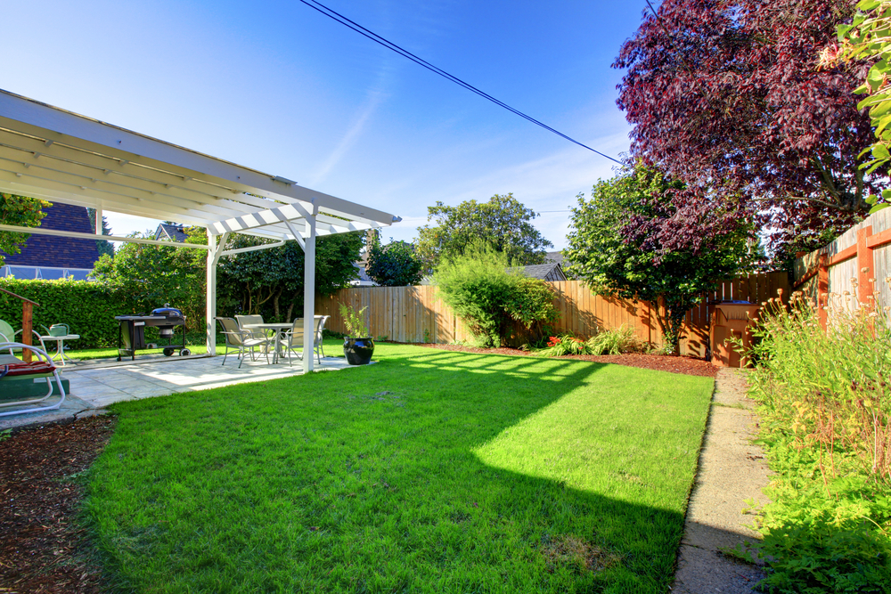
Garden Maintenance Tips to Prevent Pests
One of the best ways to manage pests is to prevent them from settling in your garden in the first place. You can do this by removing things that attract pests, such as food, water, and shelter. Here’s how:
- Remove trash and yard waste – Trash and decaying plant material often attract insects and rodents. Remove and properly dispose of any trash or yard waste.
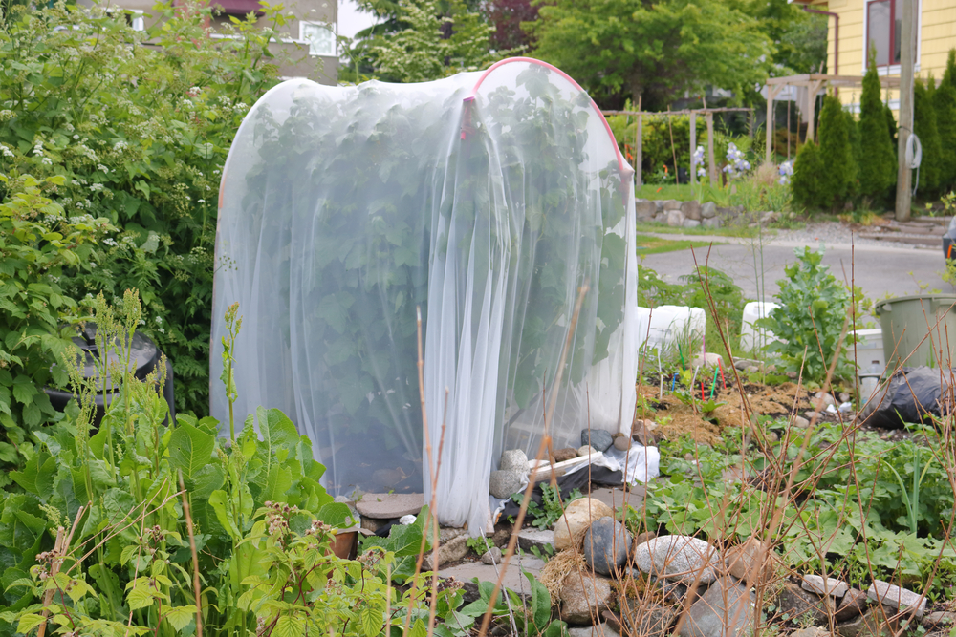
- Use physical barriers – Row covers, hot caps, and other plant cages can help keep pests away from sensitive young plants. Sticky barriers, copper barriers, and raised beds are other options that can help protect garden plants.
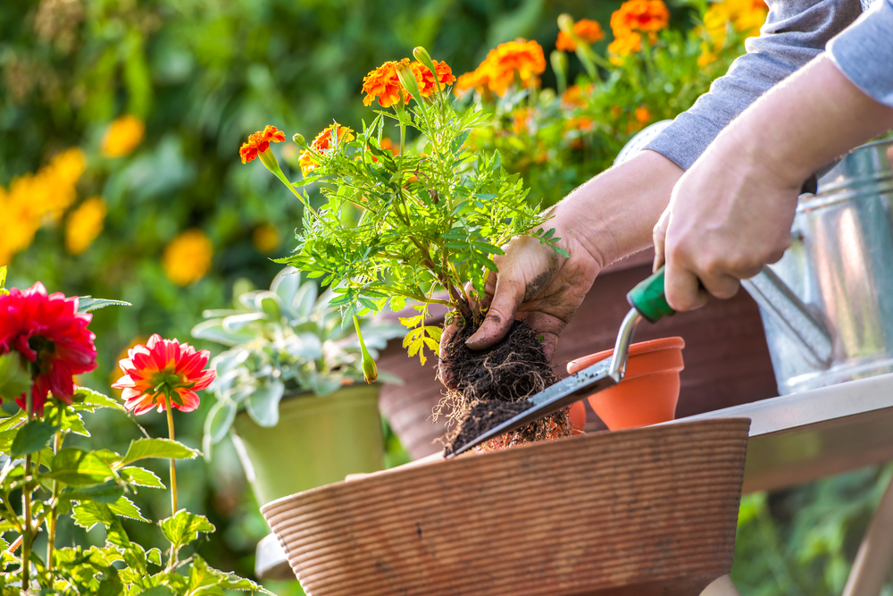
- Remove standing water – Standing water can encourage the growth of mold and algae, become a nursery for insect larvae, and attract unwanted animals looking for drinking water. Be sure to remove standing water to reduce the chances of pests turning your yard into their home.
- Plant smart – Planting strategies, such as selecting appropriate types of plants, alternating plant patterns, and adding ground cover (like mulch) can deter pests. Visit Our Water, Our World for more information about planting strategies.
Learn More!
Additional information about pest prevention can be found here.
Friend or Foe: Beneficial Insects
Most bugs are friends, not foes! In fact, 97% of the insects you see are considered good. These are called “beneficial insects” because they benefit your garden by pollinating your plants, improving the soil, and eating the pests that harm your garden. How can you invite more friends to your garden? Here are a few tips to identify and attract beneficial insects:
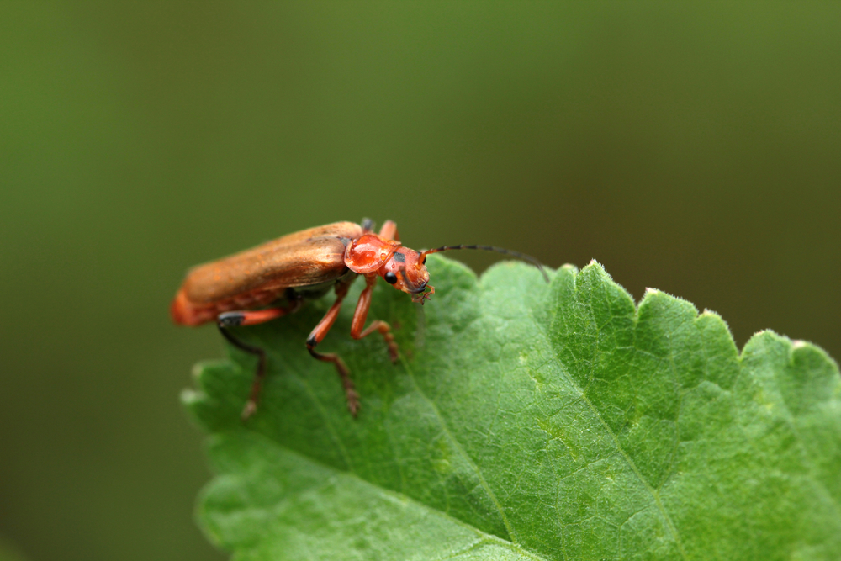
- Find your friends – Many insects are natural enemies of common pests; you just might not recognize them! Find out who your friends are by learning how to identify beneficial insects. An insect can look dramatically different during each stage of its life cycle, such as egg, larva, pupa, and adult. It is important to know what the good bugs, such as bees, ladybugs, soldier beetles, and green lacewings, look like in their various life stages.
- Plant for success – By planting native plants that are high in pollen and rich in nectar, you can increase the likelihood that beneficial bugs will find your garden welcoming and stick around.
- Use pesticides as a last resort – While pesticides can control pests efficiently, they will also likely harm or kill the beneficial bugs. If pests are present in your yard, first try non-toxic or less-toxic methods, such as traps, deterrents, and preventative measures, to ensure your gardening strategies are sustainable and environmentally friendly.
  - Did You Know? The stores where you buy pesticides can help you choose a less-toxic option! Next time you’re shopping for pest control products, look for “point-of-purchase” signs, such as shelf edging or tags, as well as display stands with fact sheets, banners, and other educational materials. Our Water, Our World is one program that provides these materials in northern California. Click here to find a participating store near you.
Learn More!
Visit the UC Integrated Pest Management Program for more resources on pesticide best practices.
For more information about how your local is working toward improving local water quality, visit your local agency stormwater webpage].

Summer E-Newsletter
Don't Run Off!
Tips to Keep Water in Your Yard
Harmful runoff can occur when water (either rain or irrigation) comes into contact with and washes pesticides, soil, or other products used around your home into storm drains and waterways. You can help reduce harmful runoff and protect local waterbodies by using less-toxic products and slowing the flow of pollutants from your yard and garden.
Integrated Pest Management (IPM)
A simple way to help keep pesticides out of the local waterbodies is to reduce the amount of chemicals you apply to your yard and garden. To do this, while managing pest problems effectively, you can use Integrated Pest Management (IPM), which focuses on low- to no-pesticide methods of pest control, such as:
- Prevention – Prevent pests from becoming a problem in the first place. For more information about pest prevention, check out the spring newsletter archived Spring e-newsletter]!
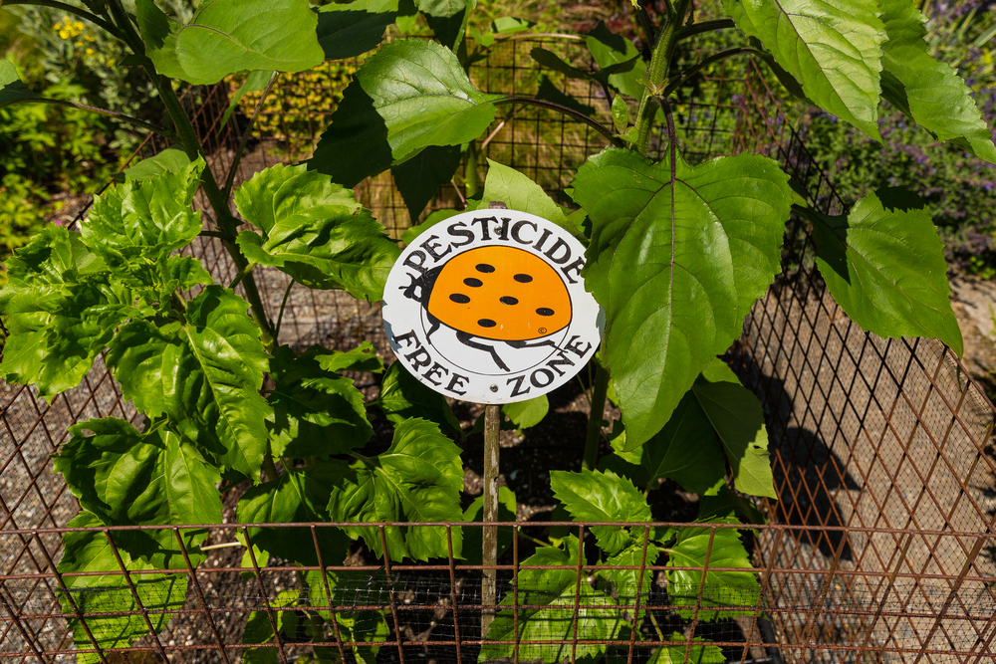
- Alternatives – Use alternatives to pesticides for pest control, such as traps, physical removal, natural deterrents, and/or natural predators.
- Pesticides as a Last Resort – Treat pesticides as a last resort, and use the least toxic options available. Discover more information about less-toxic pesticide options here.
LEARN MORE!
Visit the UC Integrated Pest Management Program website.
If you are unsure about how to safely manage your pest problem, it may be time to hire a professional to take care of the problem for you. More information about hiring IPM professionals can be found here.
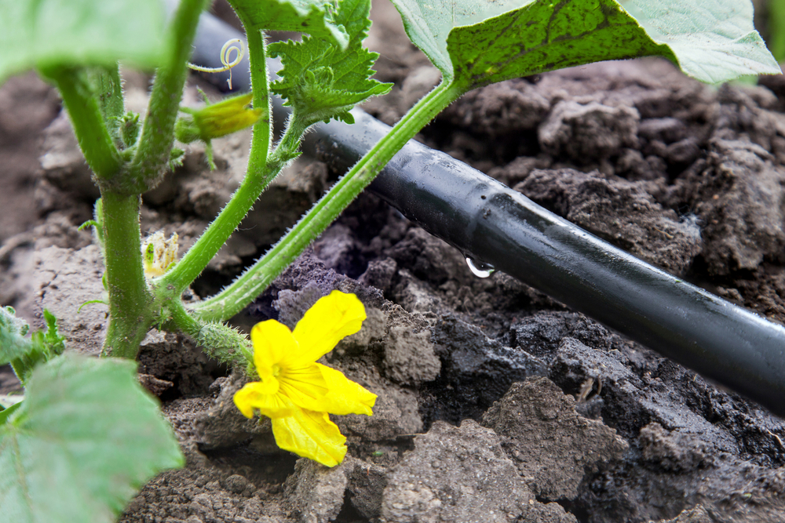
Water-Conscious Landscaping
If pesticides must be used, be sure to follow these landscaping tips to help keep water and chemicals in your yard and out of our creeks and rivers.
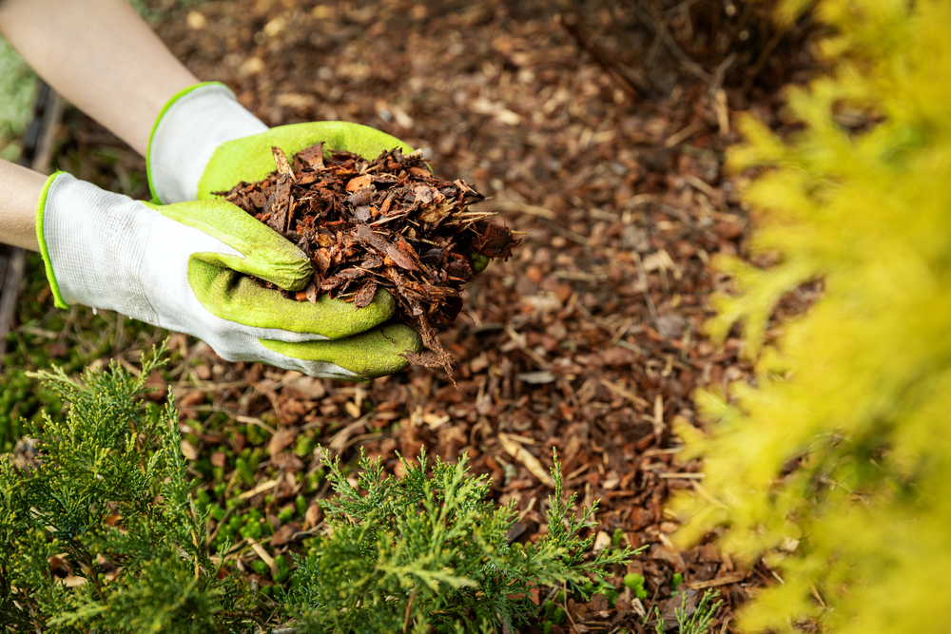
- Avoid Overwatering – Overwatering and overspray will lead to increased runoff which can carry along the pesticides you apply. Find more information about how to irrigate responsibly here.
- Porous Surfaces – Use gravel, stones, or pavers to allow water to soak into the soil in areas where you don’t have plants. Consider adding mulch to your garden to keep your soil moist, reduce evaporation, and restrict weed growth. Check out these additional landscaping tips!
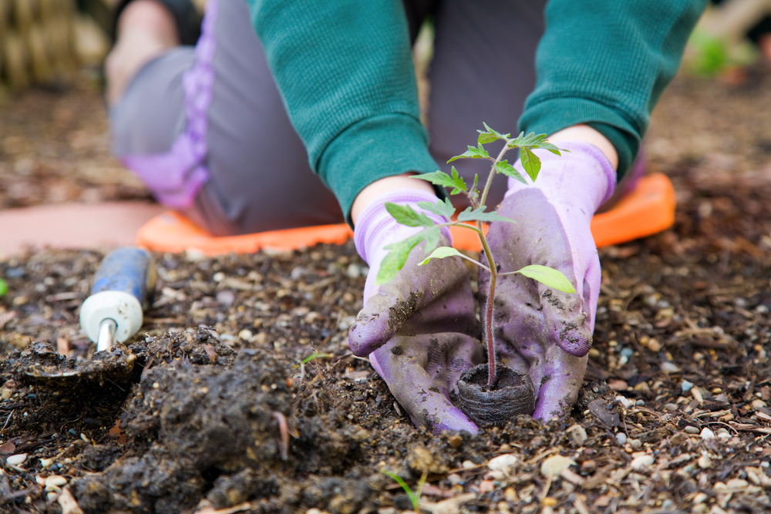
- Plant Native – Plant vegetation that is naturally found in California ecosystems and requires little to no watering. This reduces the need for irrigation, as well as the potential for harmful runoff. Find native plants for your garden by using this Calscape tool.
- Timing – Wet and windy weather can spread pesticides to unintended places. Be sure not to apply pesticides (especially sprays) on windy days or right before a rainstorm. Learn more about safely applying pesticides here.

For more information about how your agency is working toward improving local water quality, visit your local agency stormwater webpage].

FALL E-NEWSLETTER
Know When to Go Pro
Advice for Hiring Landscape & Pest Control Professionals
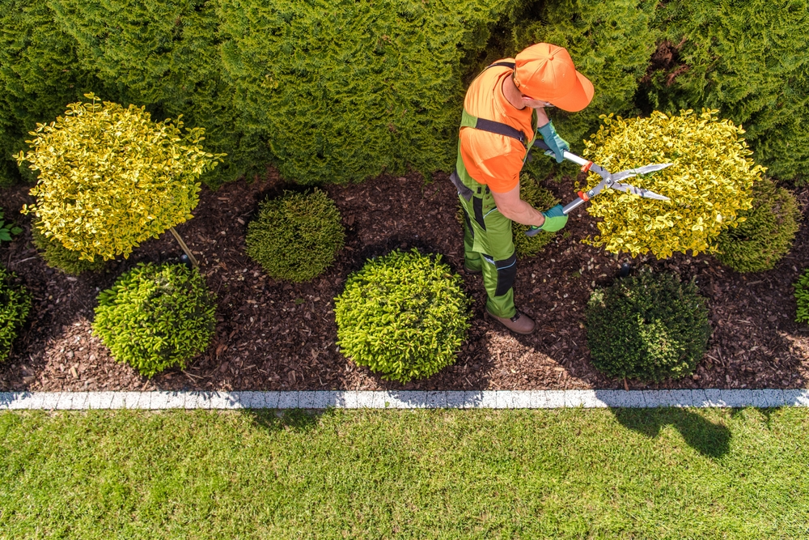
Don’t have the time or equipment to safely manage your pest problem yourself? Then it’s time to hire a pest control service to do the job for you! To effectively manage large or ongoing pest problems, licensed professionals have specialized equipment, pesticides, and technical training to get the job done. A landscape or pest control professional who practices Integrated Pest Management (IPM) methods and stays up to date on the latest information can provide you with the safest and most effective management strategies.
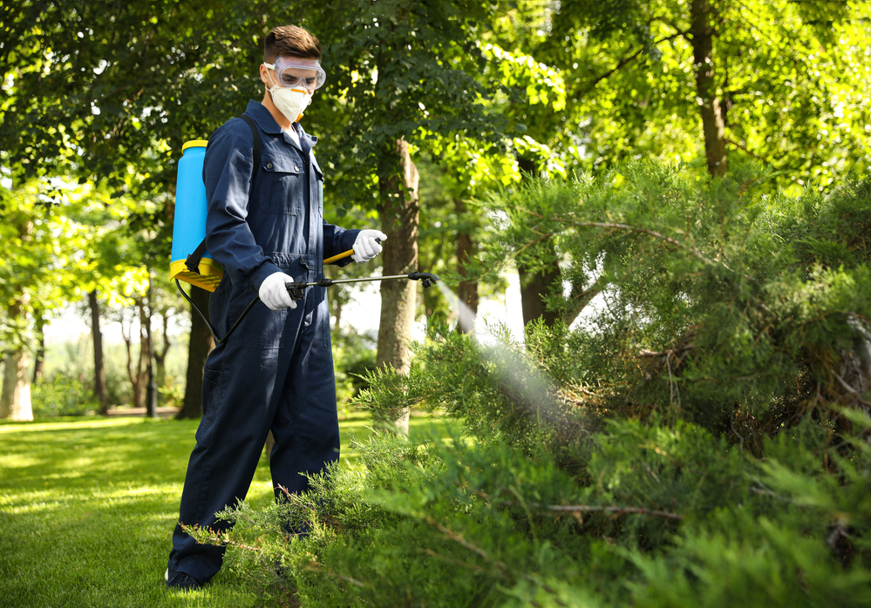
Here's what to do before you hire a landscape or pest control professional:
- Consider your options – Inquire with pest control companies about their methods and policies to see what option best suits your needs and pest problem.
- Check certifications – Make sure the company has the required licenses, registration, certificates, and insurance. Verify the status of a pest control company's license here.
- Ask about Integrated Pest Management (IPM) – IPM is an eco-friendly and effective method of pest control. Before hiring, check if your pest control or landscaping professional practices IPM. Three programs that certify and list pest control companies that provide IPM services are EcoWise, GreenPro, and Green Shield.
Learn More!
Visit Our Water, Our World or the UC Integrated Pest Management Program for more information about hiring a professional pest control or landscaping company.
Dispose of Pesticides Like a Pro
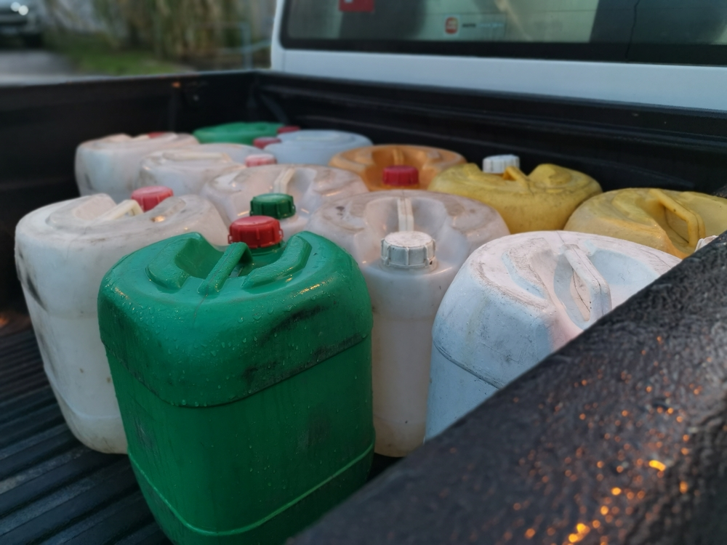
Do you have any unused pesticides (liquid or solid) around your home that you no longer need? These items must be disposed of properly so that they do not harm you or the environment. Any leftover pesticides must be taken to your local household hazardous waste facility. You may only dispose of empty, unrinsed pesticide containers in the trash.
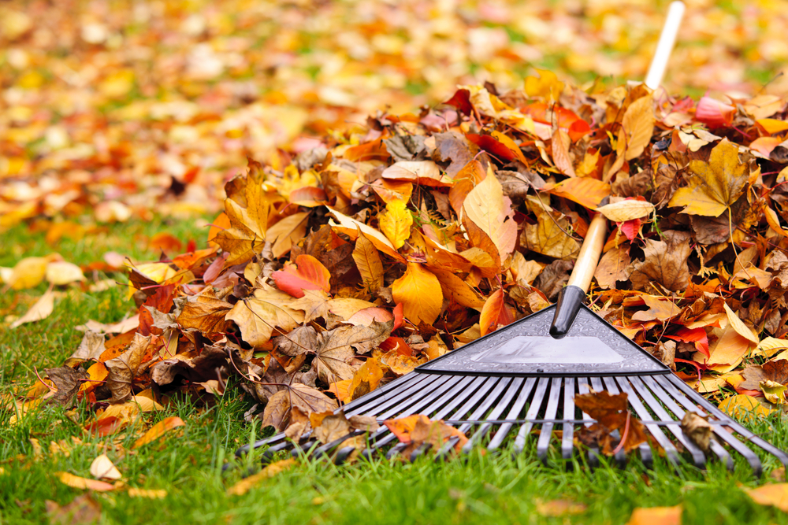
Contract your local agency to obtain information regarding the household hazardous waste facility locations and events.
Go Green with Green Waste
Whether you decide to maintain your own yard or choose to hire a landscaper, it’s important to know how to properly dispose of yard waste to prevent plant material (e.g., leaves, branches, and trimmings) from clogging local storm drain systems.
Wondering what to do with your leaves and other yard waste this fall? Contact your local agency to obtain agency-specific information about fall leaf/green waste collection.
For more information about how your local agency is working toward improving local water quality, visit their local agency website.

Winter E-Newsletter
Waters Will Flow
Stormwater and Pesticides
California’s wet weather season typically falls between October and April, and stormwater runoff from these seasonal storms can have a big impact on our local water quality.
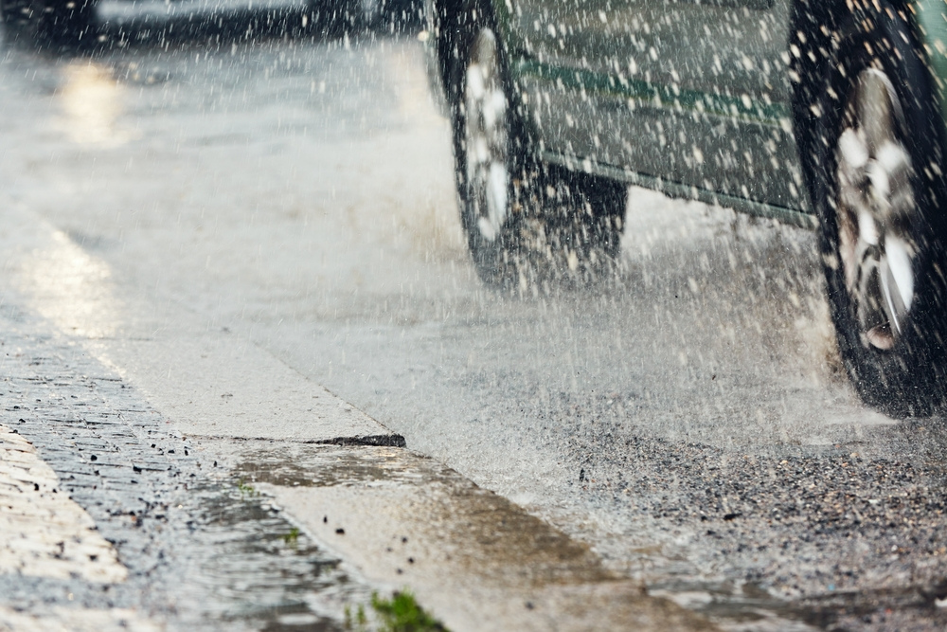
Stormwater is water from rain or snowmelt that flows over the landscape. This water can then travel, untreated, into the storm drain system and ultimately to the local waterbodies. As the stormwater comes into contact with the urban landscape it can become contaminated with substances such as motor oil, pet waste, trash, and pesticides, which can harm our waterways.
Pesticides and Water Quality
Pesticides are toxic chemicals that are intended to kill pests, such as unwanted insects and plants. However, if these chemicals end up in our waterways, they can harm the aquatic plants and animals.
Follow these tips to help keep pesticides out of our streams and rivers:
- Consider less-toxic alternatives first. Visit Our Water, Our World to learn more.
- Always read product labels and follow the instructions when applying chemicals.
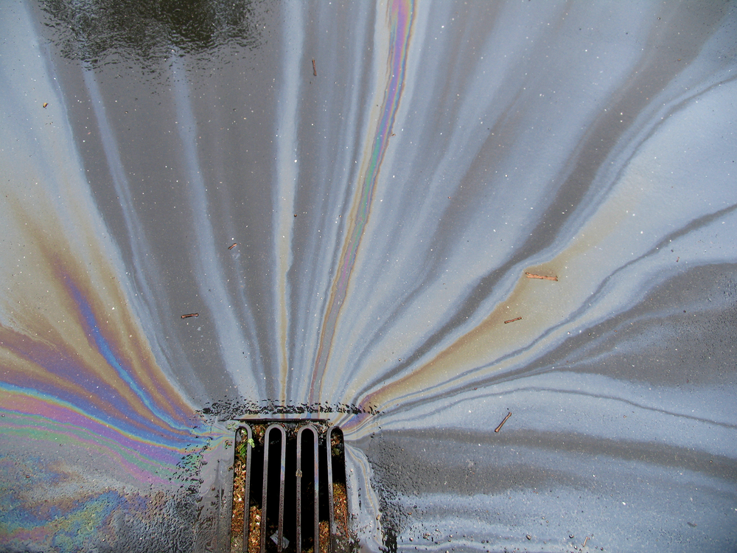
- Choose ready-to-use products instead of concentrates to reduce the risk of spills and chemical exposure.
  - If you do spill a pesticide, clean it up immediately by using something absorbent, like cat litter, sawdust, or paper towels, to soak up the chemical. Dispose of the absorbent material at a household hazardous waste facility. Never wash a spilled pesticide into the street or a storm drain!
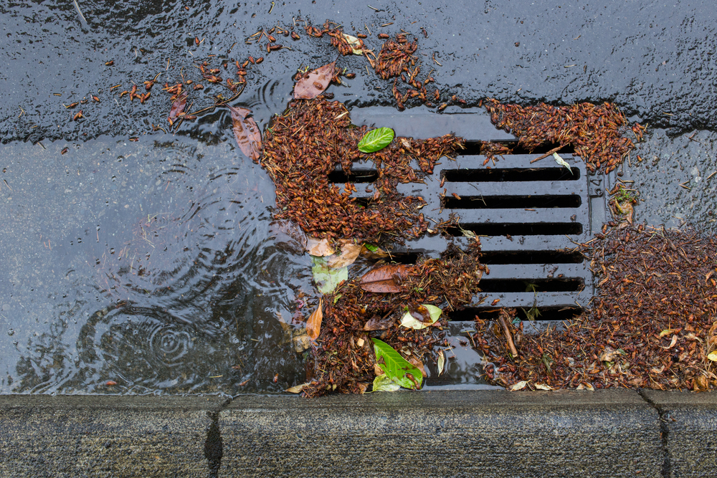
  - More information regarding your local household hazardous waste facility locations, contact your local agency.
- Be aware of your water usage. Prevent contaminated water from entering local waterbodies by avoiding watering plants soon after pesticide application and by following these irrigation tips.
Learn More!
Visit Our Water, Our World for more information about safely using and disposing of pesticides.
Pyrethroid Pesticides in Our Water
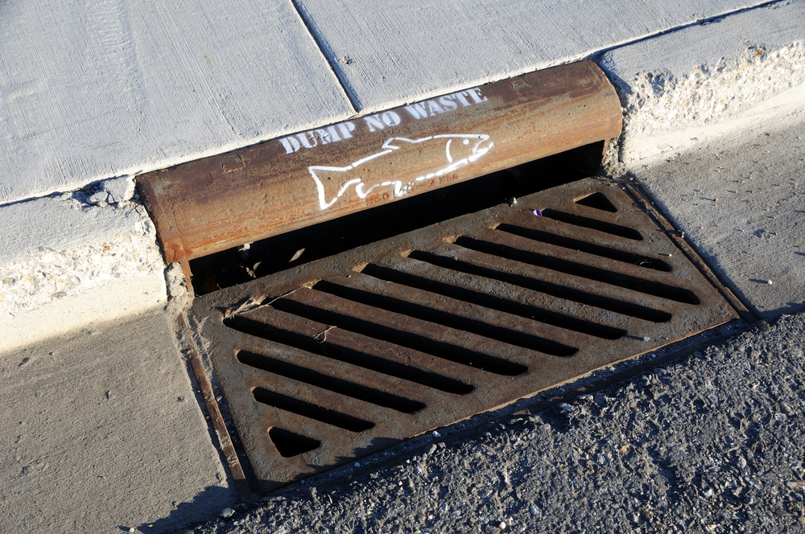
Pyrethroids are man-made chemicals found in many pesticide products because they’re good at managing pests. However, these chemicals can become a problem in our waterbodies because they don’t break down in the environment easily and can continue to harm aquatic plants and animals long after the pesticide is applied. Pyrethroid active ingredient names almost always end in -thrin. Be sure to read the labels of pesticide products and avoid products with the following active ingredients, if possible:
- Permethrin
- Bifenthrin
- Cyfluthrin
- Beta-cyfluthrin
- Cypermethrin
- Deltamethrin
- Lambda-cyhalothrin
- Tralomethrin
- Esfenvalerate (an exception to the -thrin rule!)
If you’re interested in purchasing less-toxic pesticide products, next time you’re at your local garden supply store, be sure to look for “point-of-purchase” displays, such as shelf edging or tags, display stands with fact sheets, banners, and other educational materials. Our Water, Our World is one program that provides these materials in northern California. Click here to find a participating store near you.
For more information about how your agency is working toward improving local water quality, visit your local agency stormwater webpage].

External References (Hyperlinks)
The hyperlinks embedded throughout the e-newsletter content are provided below, organized by the e-newsletter section within which they should be linked.

E-Newsletter Content, Distribution, and Schedule
- MailChimp: https://mailchimp.com/
- Constant Contact: https://www.constantcontact.com/
- HubSpot: https://www.hubspot.com/
- MailerLite: https://www.mailerlite.com/
- GetResponse: https://www.getresponse.com/

SPRING E-NEWSLETTER
Garden Maintenance Tips to Prevent Pests
- Our Water, Our World: Planting a Healthy Garden: https://ourwaterourworld.org/healthy-garden/
- US EPA: Introduction to Integrated Pest Management: https://www.epa.gov/ipm/introduction-integrated-pest-management#prevent
Friend or Foe: Beneficial Insects
- Our Water, Our World: Planting a Healthy Garden: https://ourwaterourworld.org/healthy-garden/
- Our Water, Our World: Find a Store: https://ourwaterourworld.org/find-a-store/
Learn More!
- UC IPM: Pesticides: Safe and Effective Use in the Home and Landscape: http://ipm.ucanr.edu/PMG/PESTNOTES/pn74126.html.

Summer E-Newsletter
Integrated Pest Management (IPM)
- Our Water, Our World: Pesticides and Water Quality: https://ourwaterourworld.org/pesticides-and-water-quality/.
LEARN MORE!
- UC IPM: http://ipm.ucanr.edu/
- UC IPM: Hiring a Pest Control Company: http://ipm.ucanr.edu/PMG/PESTNOTES/pn74125.html.
Water-Conscious Landscaping
- CDWR: Water-Efficient Landscaping: https://water.ca.gov/Water-Basics/Conservation-Tips/Plant-and-Landscape-Guide
- US EPA: Landscaping Tips: https://www.epa.gov/watersense/landscaping-tips
- Calscape Garden Planner: https://gardenplanner.calscape.org/
- UC IPM: Proper Use of Pesticides: http://ipm.ucanr.edu/WATER/U/safeuse.html

FALL E-NEWSLETTER
Know When to Go Pro
- SPCB: Search for a License: https://www.pestboard.ca.gov/license.shtml
- EcoWise: https://www.ecowisecertified.com/ecowise_index.html
- GreenPro: https://www.npmaqualitypro.org/available-credentials/greenpro/
- Green Shield: https://greenshieldcertified.org/
Learn More!
- Our Water, Our World: Hiring a Pest Control Company: https://ourwaterourworld.org/hiring-a-pest-control-company/
- UC IPM: Hiring a Pest Control Company: http://ipm.ucanr.edu/PMG/PESTNOTES/pn74125.html

Winter E-Newsletter
Pesticides and Water Quality
- Our Water, Our World: https://ourwaterourworld.org/
- CDWR: Water-Efficient Landscaping: https://water.ca.gov/Water-Basics/Conservation-Tips/Plant-and-Landscape-Guide
Learn More!
- Our Water, Our World: Pesticide Use and Disposal: https://ourwaterourworld.org/pesticide-use-and-disposal/
Pyrethroid Pesticides in Our Water
- Our Water, Our World: Find a Store: https://ourwaterourworld.org/find-a-store/

