Overview
To meet the requirements of the Pyrethroid Control Program, agencies need to implement several education and outreach activities that encourage management practices to minimize pesticide use and runoff. The requirements that will be addressed, in part, using a web-based outreach mechanism include residential outreach, outreach regarding pest control and landscape professionals, and outreach for landscape and irrigation practices (Table 1 and Table 2). The purpose of this document is to identify a framework and content for each page and sub-page of the web-based interface. Once the content is finalized, it can then be incorporated into one or more websites and shared amongst agencies, as needed.
Table 1. Recommended Activities from Scope of Work
Recommended Activity / Outreach Mechanism | Basin Plan Amendment Requirement
Recommended Activity / Outreach Mechanism | Residential | Point-of-Purchase | Pest Control and Landscape Professionals | Landscape and Irrigation Practices
Website | 
Table 2. Pyrethroid Control Program Requirements to Be Addressed via Web-Based Outreach
Basin Plan Amendment Requirement | Pyrethroid Management Plan Component
Undertake targeted outreach programs to encourage communities within a discharger’s jurisdiction to reduce their reliance on pesticides that threaten water quality, focusing efforts on those most likely to use pesticides that threaten water quality, potentially by working with DPR, County Agricultural Commissioners, and the University of California Statewide Integrated Pest Management Program, or other entities as appropriate. | Residential Outreach
Conduct outreach to Permittee’s residents and businesses who may hire structural pest control and landscape professionals that contains messages that (a) explain the links between pesticide usage and water quality; and (b) provides information about structural pest control IPM certification programs and IPM for landscape professionals. | Outreach [Regarding] Pest Control and Landscape Professionals
Encourage public and private management practices (e.g., landscape design, irrigation management, etc.) that minimize pesticide runoff. | Outreach for Landscape and Irrigation Practices

Website Framework
The website organizational framework, or site map, is summarized within this section. To ensure that the applicable requirements are effectively addressed, the key target audiences (i.e., residents and businesses), topics, and activities were considered and incorporated into proposed website section titles (Table 3). This framework also provides a placeholder to link the e-newsletters and make them broadly accessible.
Table 3. Website Framework and Sections
Pyrethroid Management Plan Component | Proposed Website Sections
All Outreach | Pesticide Landing Page  - General Pesticide Information  - Pyrethroid Pesticides  - Point-of-Purchase  Learn More  - Contact Us  - Subscribe to the E-Newsletter  - E-Newsletter Archive
Residential Outreach | Information for Residents  - Pesticides and Gardening  - Disposing of Pesticides
Outreach Regarding Pest Control and Landscape Professionals | Information for Residents  - Hiring Pest Control and Landscape Professionals  Information for Businesses  - Hiring Pest Control and Landscape Professionals
Outreach for Landscape and Irrigation Practices | Information for Residents  - Landscape Design and Irrigation Management to Reduce Pesticide Runoff  Information for Businesses  - Landscape Design and Irrigation Management to Reduce Pesticide Runoff

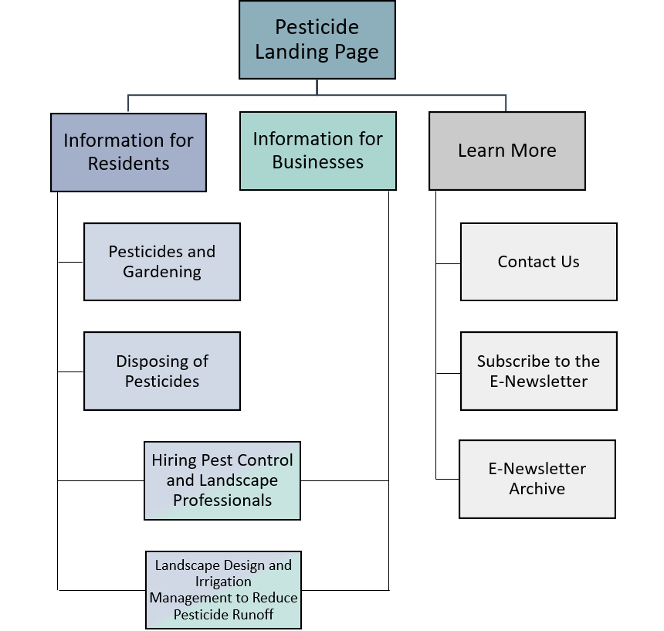
The framework is structured such that website visitors will be greeted with a Pesticide Landing Page, which will provide basic pyrethroid pesticide information and link to other webpages directed to the key target audiences. This site map is presented in Figure 1; note that there is some overlap between the information to be provided for residents and businesses. The website content is detailed in Section 3.

Figure 1. Website Site Map

Website Content
The content for each page is provided within this section. The information covered is consistent with the Basin Plan Amendment requirements, as well as the individual agency Pyrethroid Management Plans that were submitted to the Central Valley Regional Water Quality Control Board. The presentation of information in this section has been streamlined from the site map in Figure 1 and is organized as follows:
Pesticide Landing Page (Section 3.1)
- General Pesticide Information
- Pyrethroid Pesticides
- Point-of-Purchase
Information for Residents (Section 3.2)
- Pesticides and Gardening
- Disposing of Pesticides
Information for Residents and Businesses (Section 3.3)
- Hiring Pest Control and Landscape Professionals
- Landscape Design and Irrigation Management to Reduce Pesticide Runoff
Learn More (Section 3.4)
- Contact Us
- Subscribe to the E-Newsletter
- E-Newsletter Archive

Pesticide Landing Page

The State of California has regulations in place to protect water quality in the Sacramento and San Joaquin River watersheds, some of which include a focus on managing use of pesticides so that they do not harm aquatic life found within the streams and rivers in our communities. Such aquatic organisms include fish, reptiles, amphibians, crayfish, mussels, mollusks, and crustaceans. These regulations help ensure that least toxic pesticides or other means of controlling unwanted pests are used—instead of pesticides that could be washed off the urban landscape, untreated, into the streams and rivers. Click here for more information about how pesticides are affecting water quality and how pesticides get into our streams and rivers.
Image 1. Stream | Source: https://unsplash.com/photos/ko7Tp_LyAt4
As part of this effort, information about pesticides, less toxic alternatives to control pests, and integrated pest management for residents and businesses is provided here. Small changes made around your home or business—something as simple as not spraying a pesticide on a windy day or addressing a pest issue without using pesticides—can make a big difference in our local water quality. Look for the TAKE ACTION! items to see how you can make a difference.

General Pesticide Information
Pesticides are used to control unwanted bugs and plants (“pests”) such as insects (ants, wasps), rodents (mice, rats), weeds, or other unwanted organisms. Although efficient, even when used correctly, these chemicals can cause harm to human health or have negative consequences within the environment. Therefore, it is important to consider less toxic or other alternatives and always follow label instructions when pesticide applications are needed.
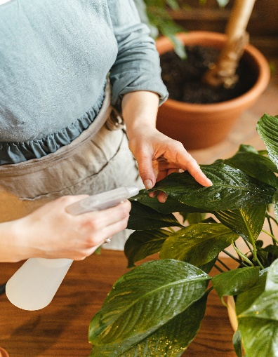
TAKE ACTION! One of the first things that you can do is to make sure that you read the label for the pesticide that you are thinking about purchasing. This will help to ensure that you understand what you are purchasing, its potential effect on the environment, and when and how it should be applied. Click here to learn more about how to read a pesticide label [Note – this links to a .pdf]or here for what to look for or here for common questions and answers about pesticide labels.
Image 2. Pesticide Bottle | Source: https://www.pexels.com/photo/woman-spraying-water-on-green-leaves-7342592/
In California, pesticides are regulated by the Department of Pesticide Regulation (DPR) as well as by the United States Environmental Protection Agency (USEPA). To learn more about why pesticides can be harmful and how they are regulated, visit the following websites:
- United States Environmental Protection Agency (USEPA)
- California Department of Pesticide Regulation (DPR)

Hyperlinks are embedded within the text and included here for informational purposes:
- US EPA: Pesticides: https://www.epa.gov/minimum-risk-pesticides/what-pesticide
- US EPA: Pesticide Labeling Questions & Answers: https://www.epa.gov/pesticide-labels/pesticide-labeling-questions-answers
- CA Department of Pesticide Regulation: https://www.cdpr.ca.gov/
- UC IPM: Pesticides and Water Quality: http://ipm.ucanr.edu/WATER/U/watqual.html
- UC IPM: How Pesticides Get Into…: http://ipm.ucanr.edu/WATER/U/stormdrain.html
- NPIC: Label graphic: http://npic.orst.edu/outreach/labelinfographic.jpg

Pyrethroid Pesticides
Although there are many different types of pesticides, one group of pesticides called pyrethroids is of particular concern because they are being found in our local waterways. Pyrethroid pesticides are primarily used for ants, cockroaches, and other insects. However, it takes them a long time to break down into less harmful components once they’re in the environment, which means that they can cause unintended harm to many other types of beneficial insects (e.g., bees, ladybugs) and aquatic life.
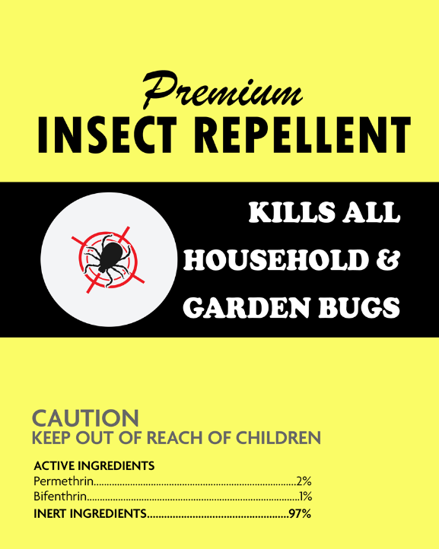
TAKE ACTION! Products that contain pyrethroids typically have active ingredients that end in “-thrin,”. When reading the pesticide label, look to see if any of the “active” ingredients include the following:
Image 3. Pesticide Label | Source: Internal Origination
- Permethrin
- Bifenthrin
- Cyfluthrin
- Beta-cyfluthrin
- Cypermethrin
- Deltamethrin
- Lambda-cyhalothrin
- Tralomethrin
- Esfenvalerate (an exception to the “-thrin” rule)
If a pyrethroid is an active ingredient, consider other ways that you might address the pest, such as other less toxic pesticides or controls that do not require the use of a pesticide
To learn more, visit Our Water – Our World: Pesticides and Water Quality.
Hyperlinks are embedded within the text and included here for informational purposes:
- Our Water Our World https://ourwaterourworld.org/pesticides-and-water-quality/

Point-of-Purchase
“Point-of-purchase” or “point-of-sale” campaigns are focused efforts to educate and raise awareness among both retailers and consumers so that they can make informed decisions about what types of products are available for sale (retailers) and what products are most effective, least harmful, and ultimately purchased (consumers). Point-of-purchase displays often include materials such as shelf edging or tags and display stands with fact sheets, banners, and other educational materials Our Water – Our World (OWOW) is an example of an established point-of-purchase program that is implemented in retail stores that sell pest control products in northern California.
TAKE ACTION! Next time you visit your local gardening and home supply retailer, look for displays and educational materials about pesticides and which controls are best for each type of pest that you may encounter. You can also click here to find stores near you that participate in the OWOW program.
[Additional information can also be provided if there are specific stores that should be highlighted or other aspects of a local program that should be noted.]
Hyperlinks are embedded within the text and included here for informational purposes:
- Our Water Our World https://ourwaterourworld.org/our-water-our-word/
- Our Water Our World https://ourwaterourworld.org/find-a-store/

Information for Residents

Pesticides and Gardening
Unwanted insects or weeds in your lawn, garden, or home can be a source of frustration and damage the plants that you are trying to grow and maintain. Some pests can also potentially transmit disease. In order to effectively prevent or remove these pests, it is important to understand what can attract or is attracting them, how they are entering the home or garden, and what control is best for that specific pest. Approaching pests in this manner will save money, have a longer-lasting effect on the pest, and protect the environment.
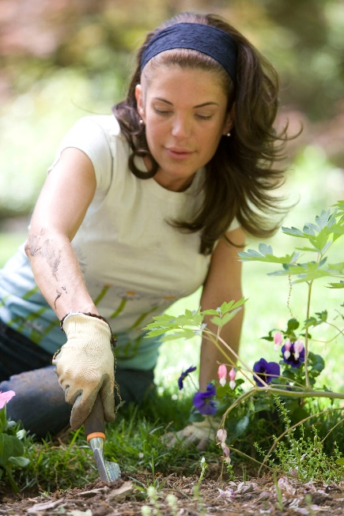
TAKE ACTION! The next time you need to address a pest in your home or garden, follow the steps below.
Image 5. Gardening | Source: https://unsplash.com/photos/_Vq-x0tE38o
- Identify if the Bug is Good or Bad
Make sure that the bug you are seeing is not a beneficial insect that actually helps plants by eating the “bad” bugs and pollinating the plants. Click here for the 10 Most Wanted Bugs in Your Garden [Note – this links to a .pdf] or here to identify typical beneficial insects.
- Identify What Controls are Best for Your Pest
Once you have identified the pest you are trying to control, look for the types of controls that will be most effective for that specific pest. The OWOW partnership and the UC Integrated Pest Management Program have detailed information that can help you determine the best method.

- Ants
- Aphids
- Bed Bugs
- Cockroaches
- Fleas
- Moles, Voles, Gophers
- Mosquitos
- Rats and Mice
- Snails and Slugs
- Spiders
- Yellow Jackets
- Individual or Multiple Weeds

- Consider No or Less Toxic Alternatives
First, try control pests with less toxic methods, such as traps, mulch, insecticidal soap, or beneficial insects like ladybugs. To learn more about less toxic pest management methods and products, visit the OWOW partnership or University of California.
- If You Must Use Pesticides – Follow These Best Practices
- Read labels and apply pesticides using recommended amounts and application methods.
- Use the least amount of chemical needed. Remember, more is not always better.
- Avoid application when it is windy or before it rains.
- Don’t overwater the area immediately after pesticide application. Excess water will carry the chemicals straight to the storm drain system and then to the local streams and rivers.
- Take care not to spill the product, and don’t rinse spills into the street. If a spill occurs, absorb it with sawdust or kitty litter and dispose of it in the trash. For larger spills, take absorbent material to a hazardous waste collection facility.
Additional best practices can be found here.
Hyperlinks are embedded within the text and included here for informational purposes:
- Our Water Our World https://ourwaterourworld.org/healthy-garden/#
- Our Water Our World https://ourwaterourworld.org/pesticide-ingredients/
- UC IPM: Less Toxic Insecticides http://ipm.ucanr.edu/QT/lesstoxicinsecticidescard.html
- UC IPM: How to Manage Pests http://ipm.ucanr.edu/PMG/PESTNOTES/pn74126.html

Disposing of Pesticides
If you have pesticides (liquid or solid) that you no longer need, they must be disposed of properly so that they do not harm you or the environment. Any leftover pesticides must be taken to your local household hazardous waste (HHW) facility. You can find your nearest HHW location by calling the California Environmental Hotline (1-800-253-2687). Residents may only dispose of empty pesticide containers in the trash without rinsing them.
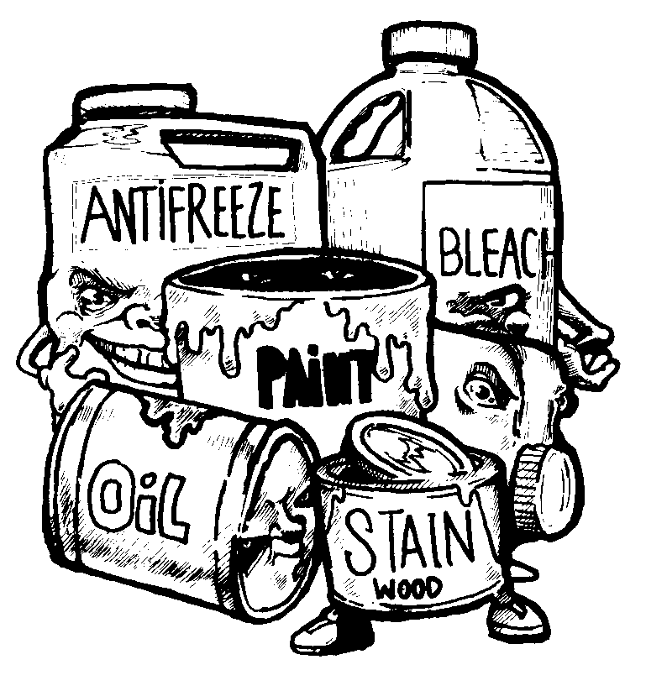
TAKE ACTION! Take your unused pesticides to [Insert information about your municipality’s local hazardous waste collection facility. Include physical address, facility hours, phone number, and website, if applicable].
Image 6. Waste Disposal | Source: https://www.calrecycle.ca.gov/usedoil/graphics/hhwart
EXAMPLE:
TAKE ACTION! Any amount of unused pesticide must be disposed of at your local household hazardous waste facility or event. Regardless of what the label may say, it is illegal in California to dispose of any amount of pesticide in the trash. To properly dispose of your unused chemicals, take them to the San Joaquin County Hazardous Waste Facility (7850 R. A. Bridgeford Street, Stockton, CA 95206). This facility is open to the public, free of charge on Thursdays, Fridays, and Saturdays from 9 AM – 3 PM. For more information, call the County Solid Waste Office at (209) 468-3066 or visit their website: https://www.sjgov.org/solidwaste/hhw.

Information for Residents and Information for Businesses
[Note: These two sections will be provided within both the “Information for Residents” and “Information for Businesses” pages.]

Hiring Pest Control and Landscape Professionals
When dealing with unwanted pests around your home or business, you may want to hire a pest control service to take care of the problem for you. Pest control professionals have access to different products, specialized training, and other equipment that may be needed in order to manage serious a serious infestation or problem.
Pest management professionals can learn more about integrated pest management approaches and available training by visiting the UC IPM Program for structural pest management or landscape pest management.
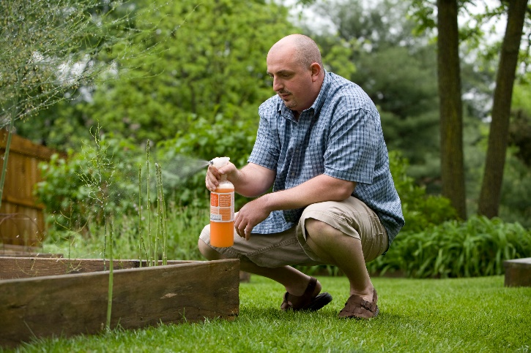
TAKE ACTION! By following these steps, you can support pest control companies that understand and implement integrated pest management and less toxic approaches.
Image 7. Pesticides in Your Garden | Source: https://unsplash.com/photos/WeLCoxy88N4
- Do some research about the pest you have and how it can be controlled.
- Ensure the pest control operator has a license issued by the California State Structural Pest Control Board and any other registrations, certifications, or insurance required. To verify the license for a pest control operator, visit the Department for Consumer Affairs.

- Hire a pest control operator who is certified as using integrated pest management practices, applies effective non-chemical strategies first, and knows how to effectively manage pests. Some questions that you can ask and things to consider can be found here and here. Several certification groups can also be helpful in finding a pest control company:
- Eco Wise Certified
- Green Shield Certified
- Green Pro Certified
Hyperlinks are embedded within the text and included here for informational purposes:
- Department for Consumer Affairs https://search.dca.ca.gov/
- OWOW – hiring a Pest Control Company https://ourwaterourworld.org/hiring-a-pest-control-company/
- UC IPM – hiring a Pest Control Company http://ipm.ucanr.edu/PMG/PESTNOTES/pn74125.html
- UC IPM – Structural https://www2.ipm.ucanr.edu/resources-for-structural-pest-management-professionals/
- UC IPM – Landscape https://www2.ipm.ucanr.edu/resources-for-landscape-professionals/?src=shrtn
- Ecowise https://www.ecowisecertified.com/ecowise_about_standards.html
- Green Shield https://greenshieldcertified.org/for-pest-control-companies/
- Green Pro https://www.npmaqualitypro.org/available-credentials/greenpro/

Landscape Design and Irrigation Management to Prevent Pesticide Runoff
Proper design and management of the landscaping around our homes and businesses can help prevent pesticide runoff from these areas into local waterbodies. Some ways to reduce your landscaping irrigation needs and keep irrigation water onsite can be found here and here.
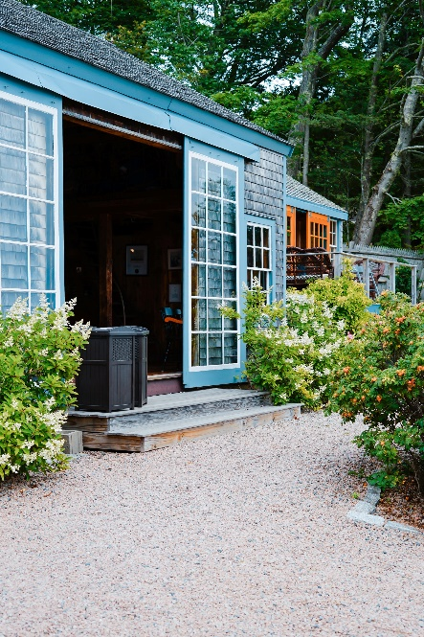
TAKE ACTION! Follow the University of California’s Statewide Integrated Pest Management Program recommendations for pesticide-smart landscape design:
Image 8. Landscape Design | Source: https://unsplash.com/photos/fv2jr89ajTE
- Install porous surfaces in unplanted areas
- Use stones, pavers, gravel, mulch, or other materials that allow water to soak into the ground in areas where you don’t have plants.
- Improve water absorption in planted areas
- Aerate your soil and use organic material, like compost, as well as perforated drainage lines, to reduce areas of water pooling in your landscaping.
- Create landscape features to collect runoff water
- Consider using trees, rain gardens, terrace walls, rain barrels, or swales (long, shallow, grassy depressions) to hold water within the landscaped area and allow it to soak into the ground rather than draining directly to our surface waterbodies.
- Install and properly operate irrigation systems and equipment
- Make sure your irrigation equipment is working properly by regularly inspecting it and consider installing a “smart” irrigation controller to reduce overwatering.
- Hyperlinks are embedded within the text and included here for informational purposes:
- CDWR Water-Efficient Landscaping https://water.ca.gov/Water-Basics/Conservation-Tips/Plant-and-Landscape-Guide
- Save Our Water https://saveourwater.com/en/
- UC IPM http://ipm.ucanr.edu/

Learn More

Contact Us
[Insert agency contact information here]

Subscribe to the E-Newsletter
Our e-newsletters contain pesticide-related information for residents and business owners. To have the e-newsletter delivered straight to your inbox: [Create a link to an e-newsletter sign-up form, or insert a sign-up form directly on the webpage]

E-Newsletter Archive
View our archive of e-newsletters to learn more about integrated pest management, less-toxic alternatives, and pesticide use and disposal: [Insert a link to the e-newsletter archive page]

